**First, I vagrant up my virtual machine deco9007/centos**

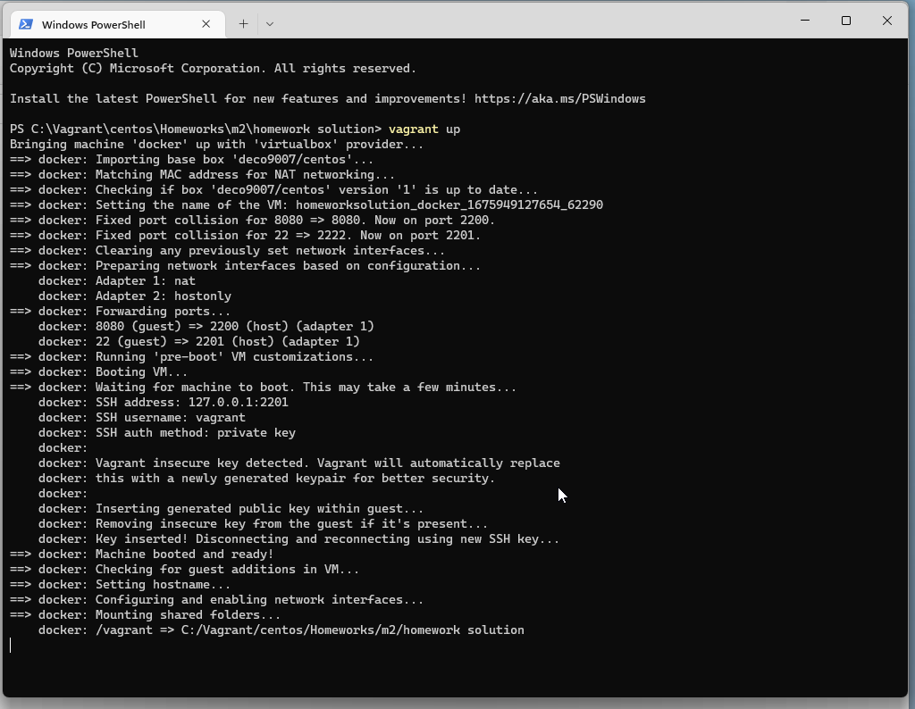

**I used the docker-setup.sh script to build VM with installed docker and the proof is:**

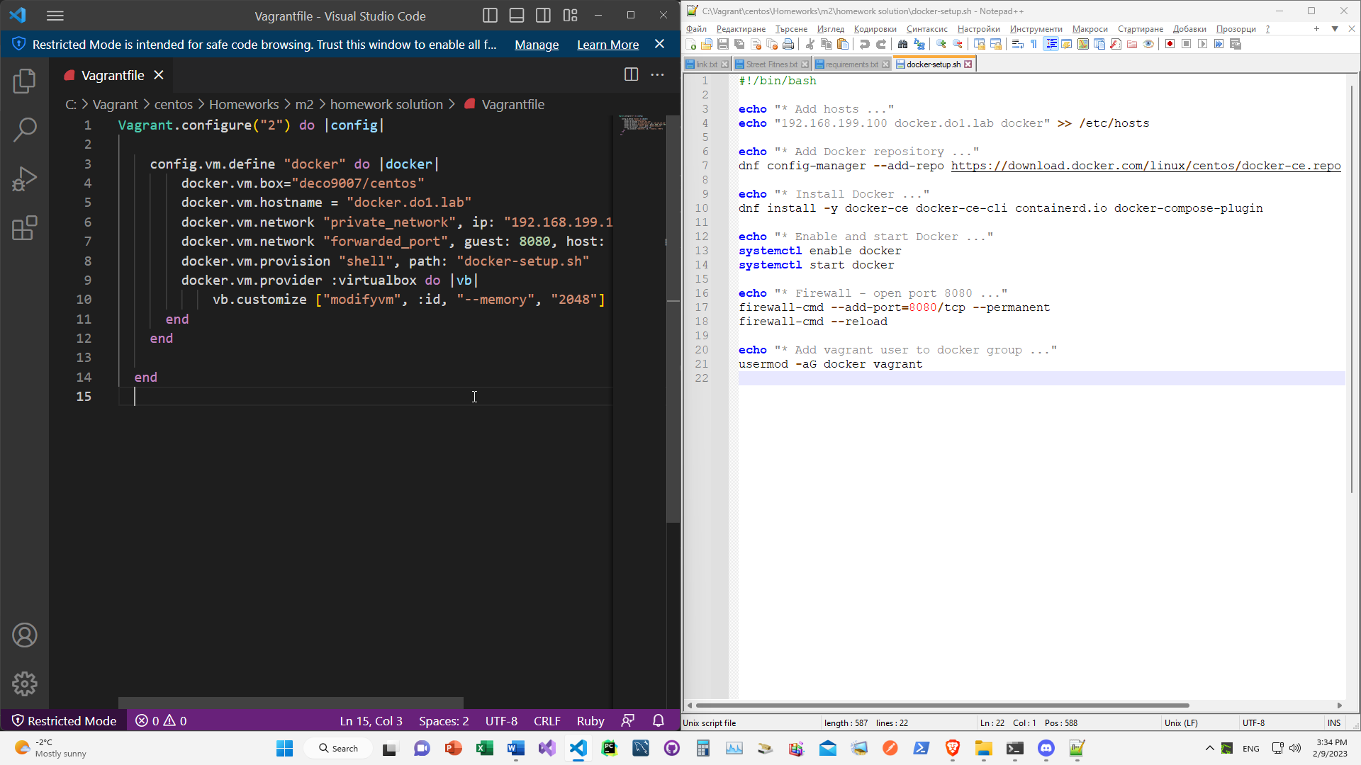

**After do vagrant ssh and connect to my new vagrant VM with installed docker.**

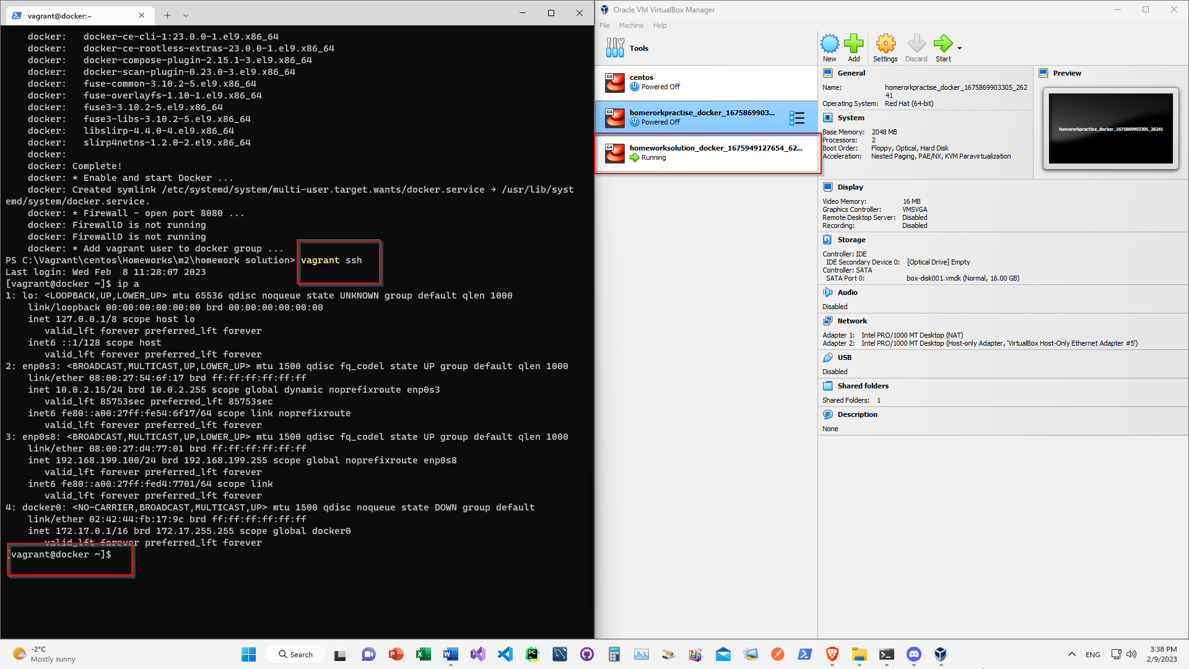

1. **I start with “ docker search CentOS “**
2. **docker image pull centos**
3. **docker image ls / To check if the image is there.**
4. 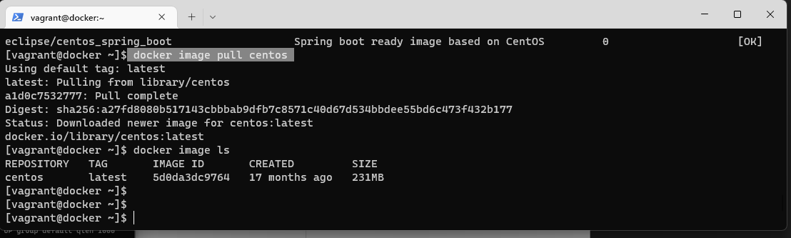
5. **make the Dockerfile:  
   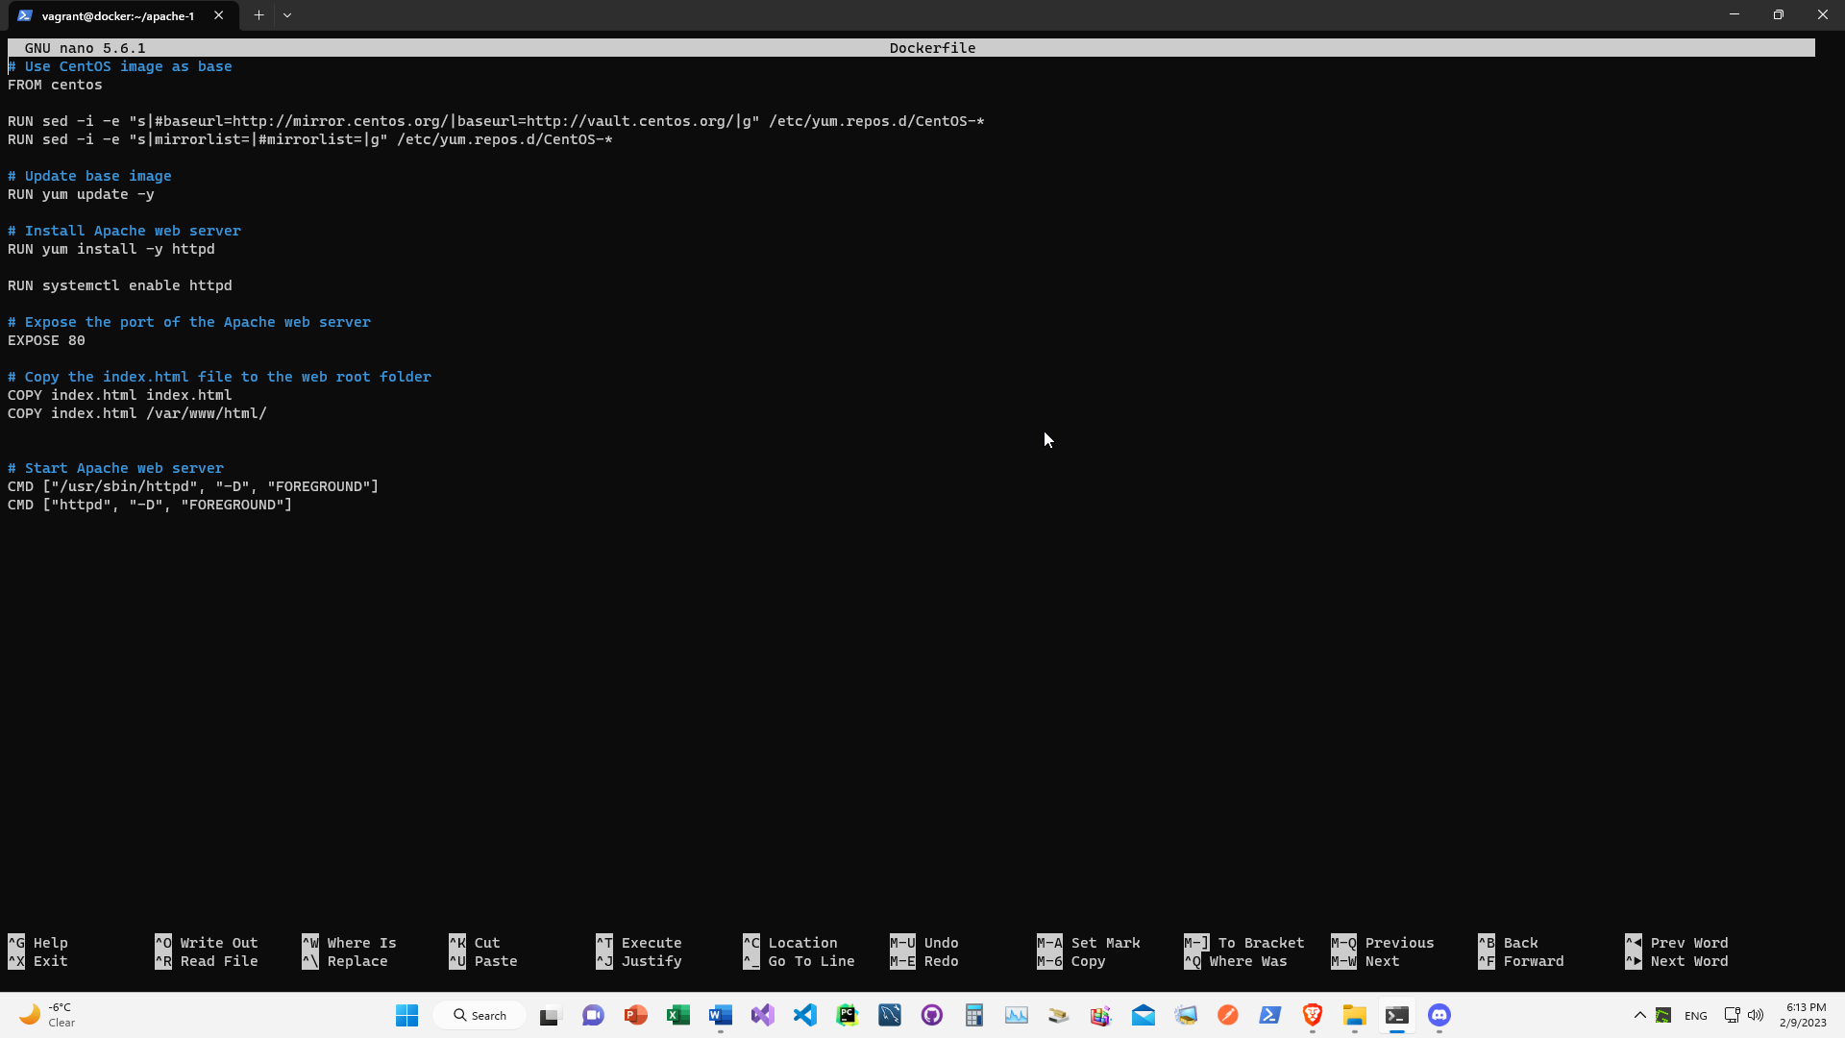**
6. **make the index.html - echo 'Hello from my first container!' > index.html**
7. **docker build -t my-first-centos-container .**
8. **docker run -p 8080:80 -d my-first-centos-container**
9. 